You are given coordinates, a string that represents the coordinates of a square of the chessboard. Below is a chessboard for your reference.

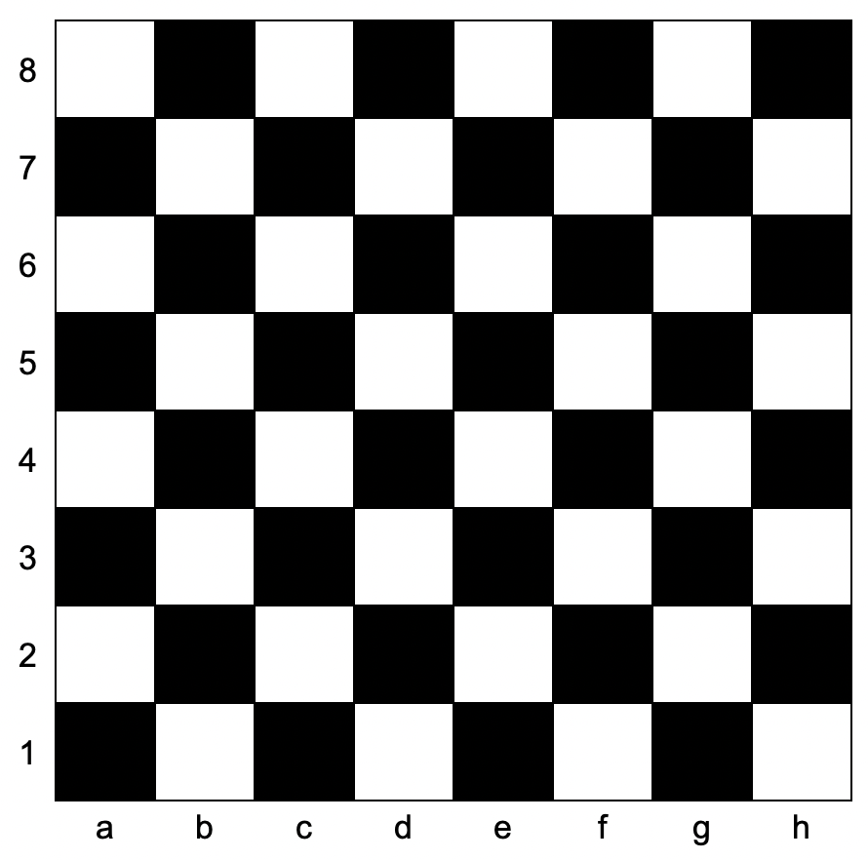

Return true*if the square is white, and*false*if the square is black*.

The coordinate will always represent a valid chessboard square. The coordinate will always have the letter first, and the number second.

**Example 1:**

**Input:** coordinates = "a1"

**Output:** false

**Explanation:** From the chessboard above, the square with coordinates "a1" is black, so return false.

**Example 2:**

**Input:** coordinates = "h3"

**Output:** true

**Explanation:** From the chessboard above, the square with coordinates "h3" is white, so return true.

**Example 3:**

**Input:** coordinates = "c7"

**Output:** false

**Constraints:**

* coordinates.length == 2
* 'a' <= coordinates[0] <= 'h'
* '1' <= coordinates[1] <= '8'